***Dine & Discovery*: A Database for Restaurant Reviews**

1. **Business Scenario Overview**

***Business Overview.*** *Dine & Discover* is a restaurant review platform designed to enhance the way people discover and explore new dining options in their area. Our platform is dedicated to providing users with a seamless and immersive journey through the diverse landscape of dining options, offering a rich tapestry of culinary experiences waiting to be discovered and savoured.

***Business Processes.*** Similarly to Yelp, users can create accounts to track restaurants they have been to, discover new restaurants, and write reviews to share their culinary experiences. Additionally, features from OpenTable are integrated as well to enhance the overall user experience in terms of booking restaurants, which is less of a focus for Yelp. This seamless process ensures that users can effortlessly immerse themselves in the vibrant world of dining discovery, fostering a community-driven platform that celebrates the joy of culinary exploration.

***Features & Functionalities.*** The platform contains a comprehensive database of restaurants within a certain area, providing information on location, cuisine types, ratings, etc. as well as offering the possibility to book a reservation directly on the platform. As for users, they can easily create an account to track their reservations and reviews, making Dine & Discover the ultimate all-in-one database for foodies. Overall, the business aims to help and support local restaurants by increasing their visibility on this review platform and creating a sense of community between the restaurants including owners, managers, etc. and general users seeking new dining recommendations, the two primary users of the platforms.

***Project Scope.*** In terms of business rules, only users who have accounts may leave reviews and all reviews must comply with community guidelines as well as only contain appropriate language. As for restaurants, they must meet certain criteria to be listed on the platform including maintaining health and hygiene standards and practices, cultural authenticity, etc. They are allowed to remain on the platform, even if they receive no reviews.

***Figure 1.*** Sample User Profile.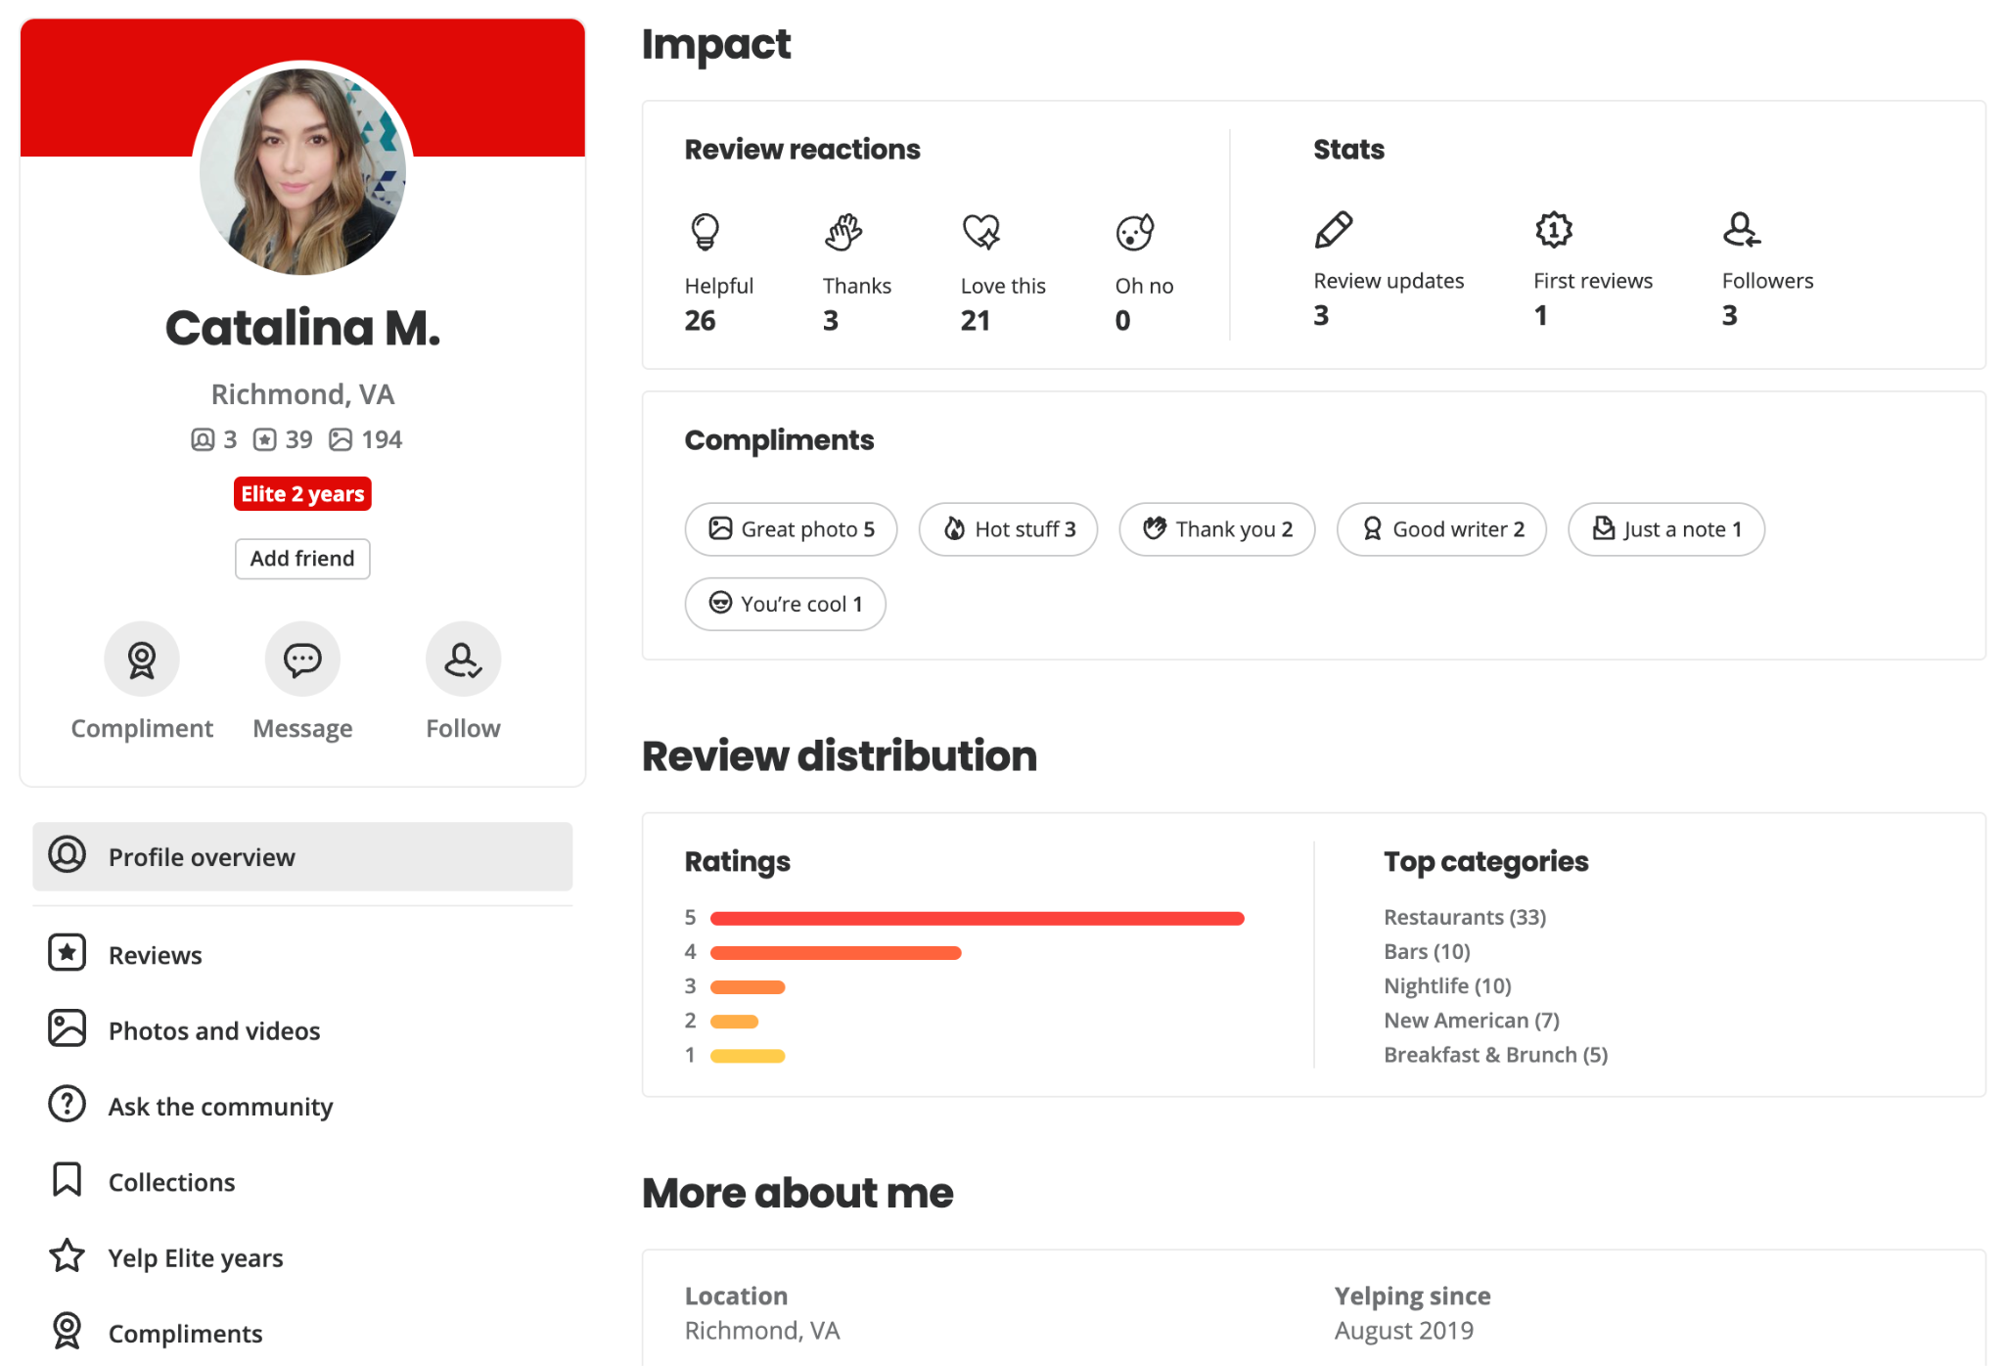

***Figure 2.*** Sample Restaurant Profile.

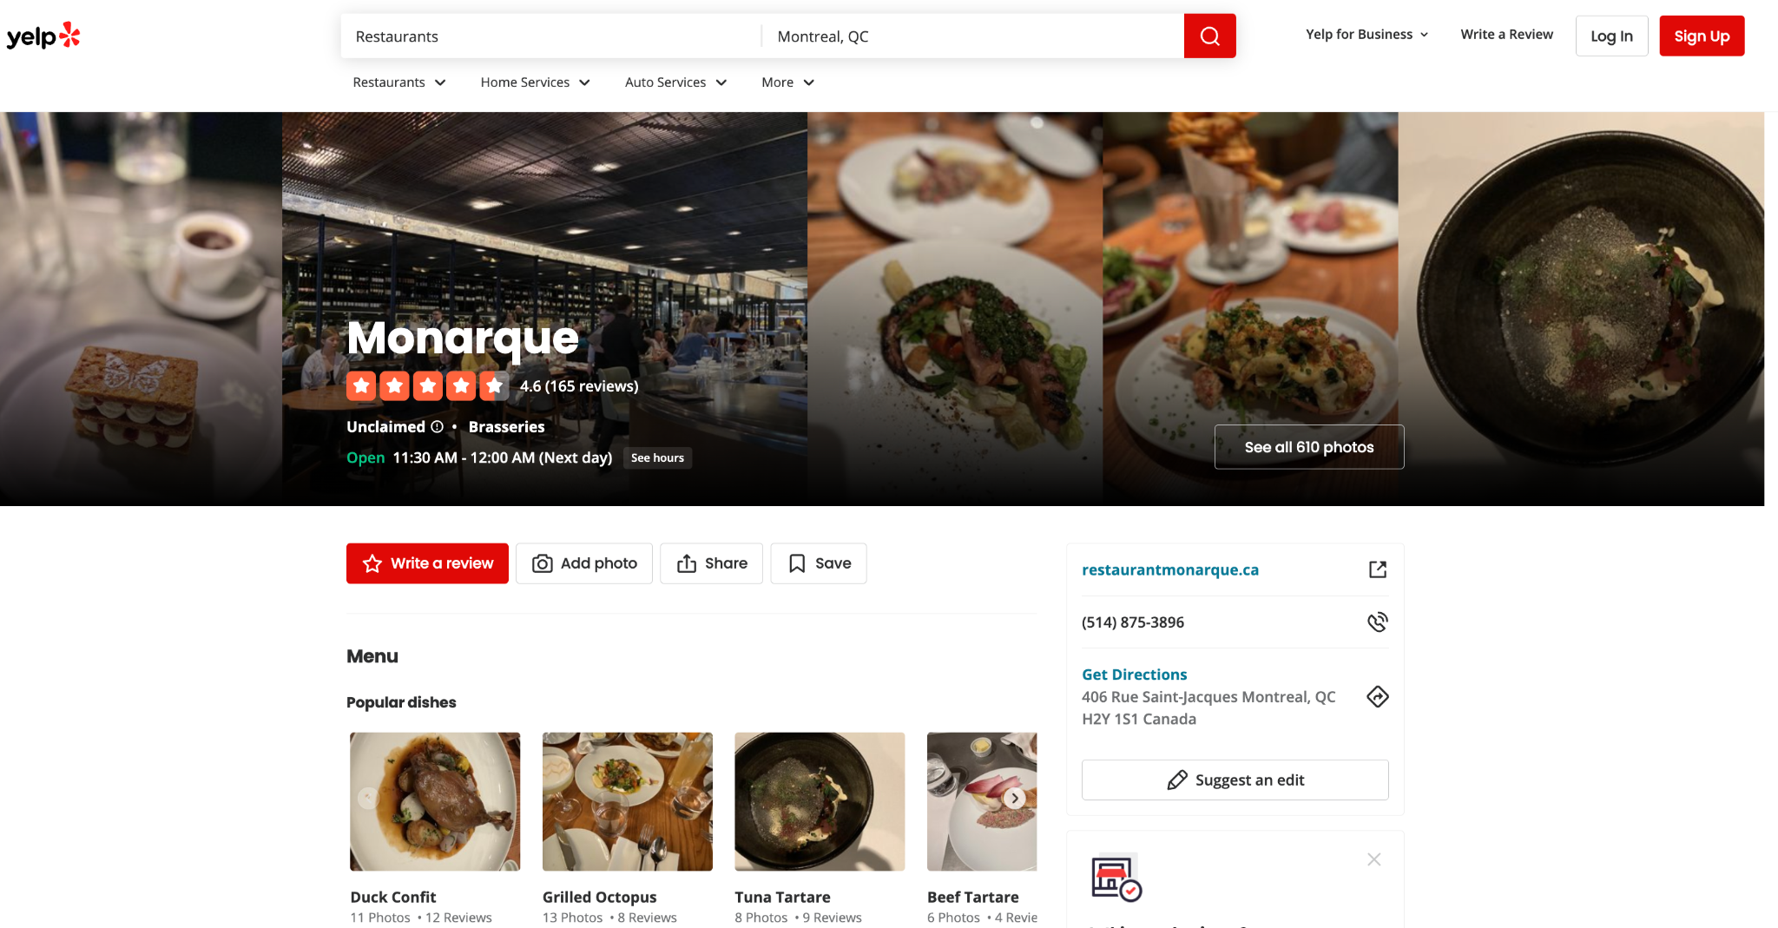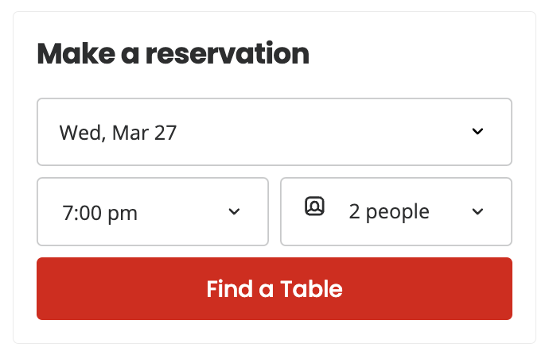

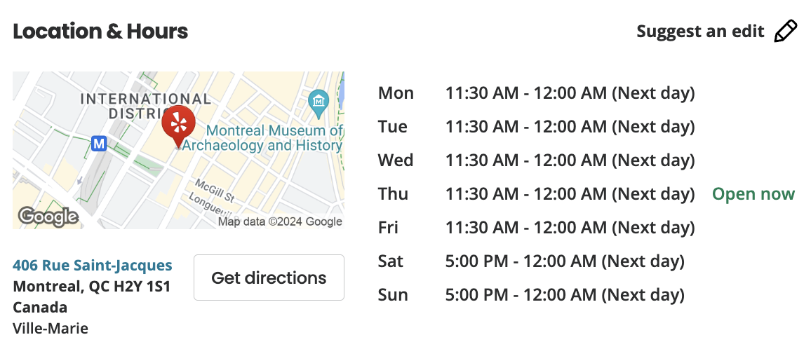

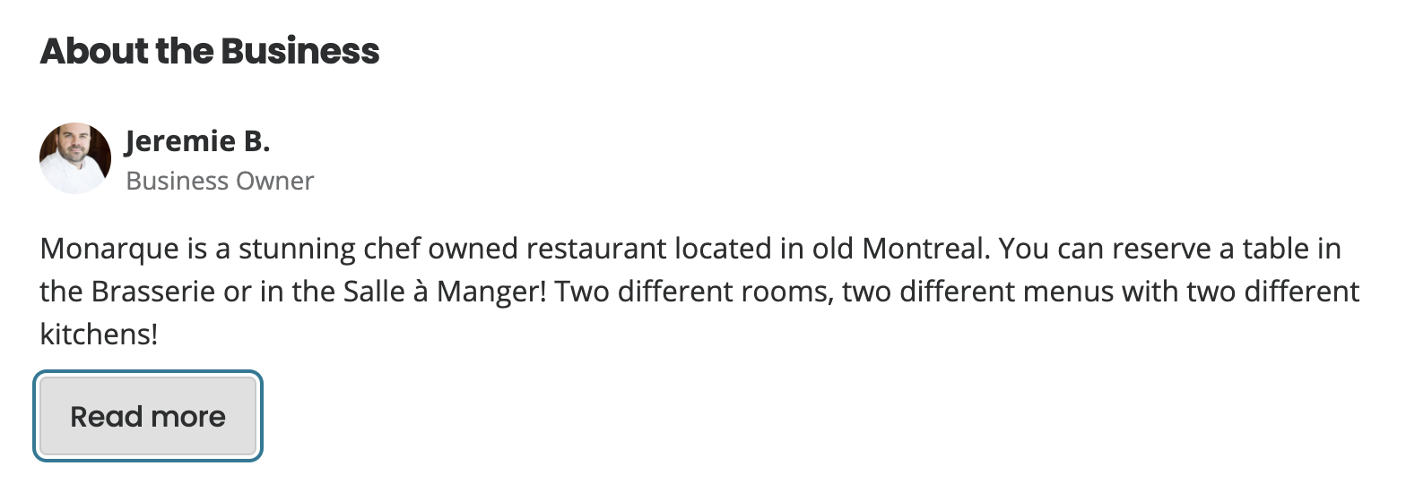

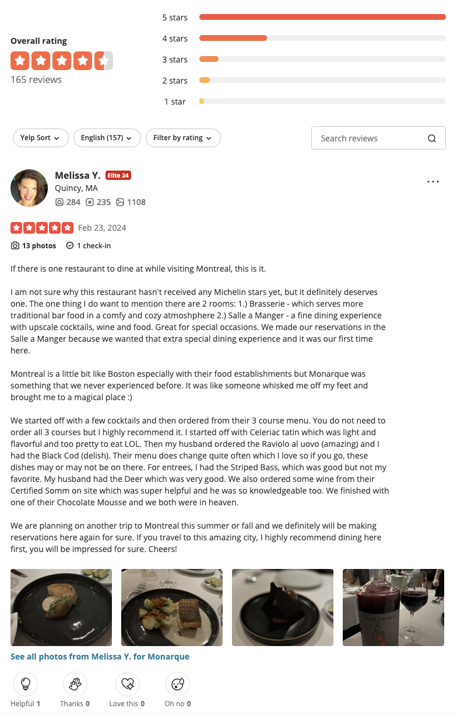

***Figure 3.*** Sample Restaurant Review.

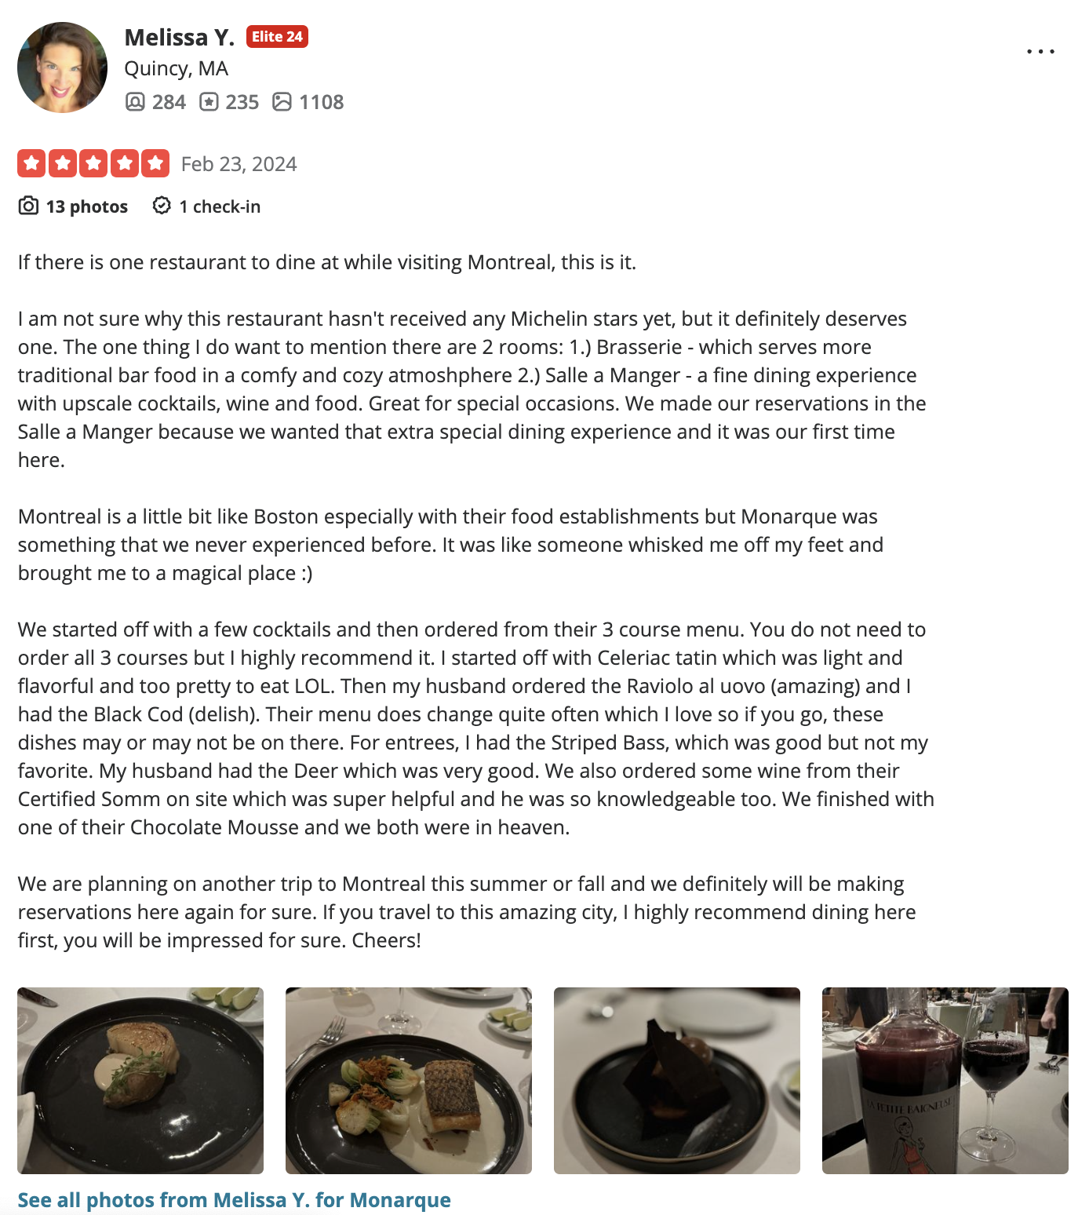

***Figure 4.*** Sample Reservation Booking.

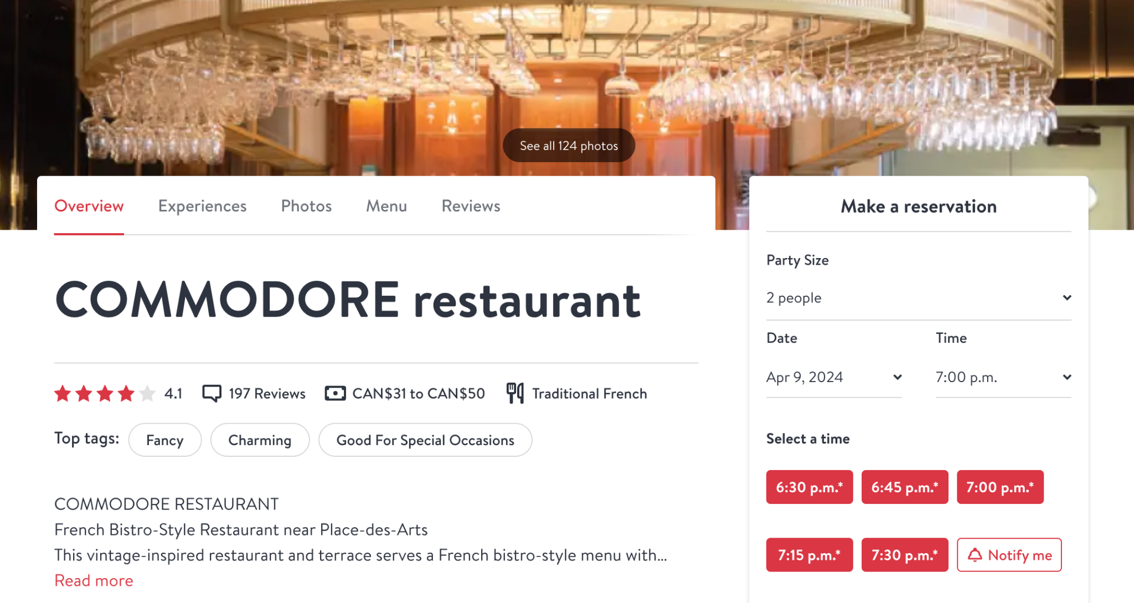

1. **Mission**

***Mission statement.*** The purpose of the *Dine & Discovery* database system is to curate and manage the data that is used and generated by customers for discovering, evaluating, and sharing dining experiences. The platform aims to foster collaboration and information sharing amongst users and restaurant owners to enhance engagement within the dining community.

***Mission objectives.*** The *Dine & Discovery* database aims to…

* Maintain (enter, update, and delete) data on restaurant addresses, reservations, restaurants, users, reviews, review likes, review photos, review comments, restaurant categories
* Perform searches on restaurant addresses, reservations, restaurants, users, reviews, review likes, review photos, review comments, restaurant categories
* Track the status of reservations, restaurants, users, reviews, comments
* To report on restaurant addresses, reservations, restaurants, users, reviews, review likes, review photos, review comments, restaurant categories

1. **Entity Relation Diagram**

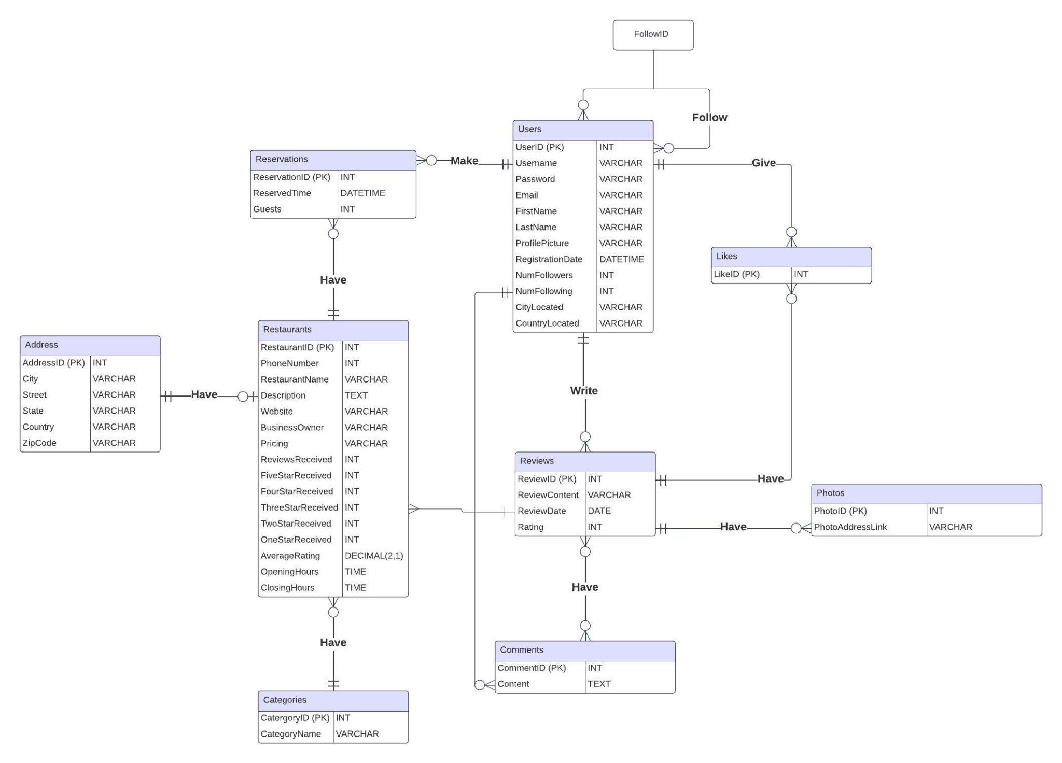

1. **Data Dictionary**

***Table 1.*** Description of the Entities.

|  |  |  |  |
| --- | --- | --- | --- |
| **Entity Name** | **Description** | **Aliases** | **Occurrence** |
| Users | Contains all the information needed to identify a user with an account on the platform. | U | Many users can write many reviews. One user can author many reviews. |
| Reviews | Contains information about a review of a restaurant, including a customer's remarks, critiques, and notes. | Rev | Many reviews can be written by many users. One user can write one review. |
| Comments | Contains information related to comments under users’ reviews. | Com | A review can have many comments. A comment can made by only one user |
| Likes | Contains information about likes given by users per restaurant review. | L | A user can give one and only one like to a post. A post can receive zero or many likes. |
| Photos | Contains information about the photo and related information to the user who posted it. | P | Many photos can be associated with many reviews. One review can include many photos. |
| Reservations | Contains all reservation information by users for restaurants. | Res | Only one reservation can be associated with only one user. A restaurant can have zero or many reservations. |
| Restaurants | Contains all the details about the restaurants that have reviews on the platform. | R | Many restaurants can receive many reviews. One restaurant can be reviewed by many users. |
| Categories | Contains an exhaustive list of the variety of restaurant categories a restaurant can be classified as. | C | Many restaurants can belong to many categories. One category can include many restaurants. |
| Address | Contains all the restaurant location information. | A | Only one address can be associated with only one restaurant. |

***Table 2.*** Description of the Attributes.

|  |  |  |  |  |  |  |  |
| --- | --- | --- | --- | --- | --- | --- | --- |
| **Entity Name** | **Attributes** | **Description** | **Data Type** | **Nulls** | **Multi-valued** | **Derived** | **Default** |
| Users | UserID (PK) | Unique ID for each user | INT | No | No | No | None |
|  | Username | Unique name for each user account | VARCHAR | No | No | No | None |
|  | Password | Unique password for each user account | VARCHAR | No | No | No | None |
|  | Email | Unique Email address registered for each user account | VARCHAR | No | No | No | None |
|  | FirstName | Unique first name for each user with account | VARCHAR | Yes | No | No | None |
|  | LastName | Unique last name for each user with account | VARCHAR | Yes | No | No | None |
|  | ProfilePicture | Unique picture in the profile of each user | VARCHAR | Yes | No | No | Null |
|  | RegistrationDate | The unique date for each user to register for the account | DATE | No | No | No | None |
|  | NumFollowers | Number of followers the user has | INT | Yes | No | Yes | 0 |
|  | NumFollowing | Number of users the user is following | INT | Yes | No | Yes | 0 |
|  | CityLocated | The city the user is currently in | VARCHAR | Yes | No | No | Null |
|  | CountryLocated | The country the user lives in | VARCHAR | Yes | No | No | Null |
| Reviews | ReviewID (PK) | The review id | INT | No | No | No | None |
|  | ReviewContent | The content within the review section | VARCHAR | No | No | No | None |
|  | ReviewDate | The date on which the review was posted | DATE | No | No | No | None |
|  | Rating | Rating for the specific restaurants ranging from 1-5 | INT | No | No | No | None |
|  | PhotoID (FK) | Unique id of the photo | VARCHAR | No | No | No | None |
|  | UserID (FK) | The username ID | INT | No | No | No | None |
|  | RestaurantID (FK) | Unique ID that identifies a restaurant | INT | No | No | No | None |
| Comments | CommentID (PK) | The id of the comment | INT | No | No | No | None |
|  | Content | The text content of the comment | TEXT | No | No | No | None |
|  | ReviewID (FK) | The review id of the review the comment belongs to | INT | No | No | No | None |
|  | UserID (FK) | The user id of the user which left the comment | INT | No | No | No | None |
| Likes | LikeID (PK) | The reaction Id to identify a reaction | INT | No | No | No | None |
|  | ReviewID (FK) | The review id | INT | No | No | No | None |
|  | UserID (FK) | The name of the reaction type | INT | No | No | No | None |
| Photos | PhotoID (PK) | Unique id of the photo | VARCHAR | No | No | No | None |
|  | PhotoAddressLink | Link of the photo | VARCHAR | No | No | No | None |
|  | ReviewID (FK) | ID of the review the photo belongs to. | INT | No | No | No | None |
| Reservations | ReservationID (PK) | The reservation id to identify a reservation | INT | No | No | No | None |
|  | ReservedTime | The time for which the reservation is booked for | DATETIME | No | No | No | None |
|  | Guests | The number of guests coming | INT | No | No | No | None |
|  | RestaurantID (FK) | The restaurant id for which the reservation is for | INT | No | No | No | None |
|  | UserID (FK) | The user id of the user who made the reservation | INT | No | No | No | None |
| Restaurants | RestaurantID (PK) | Unique ID that identifies a restaurant | INT | No | No | No | None |
|  | PhoneNumber | Unique number corresponding to the restaurant | INT | No | No | No | None |
|  | RestaurantName | Name of the restaurant (unique) | VARCHAR | No | No | No | None |
|  | Description | Description of the restaurant | TEXT | Yes | No | No | None |
|  | Website | Website of the restaurants | VARCHAR | No | No | No | None |
|  | BusinessOwner | Name of the business owner | VARCHAR | No | No | No | None |
|  | Pricing | General price point of the restaurant, i.e., $, $$, $$$, $$$$ | VARCHAR | Yes | No | No | None |
|  | ReviewsReceived | Total number of reviews received | INT | Yes | No | Yes | None |
|  | FiveStarReceived | Total number of 5-star reviews received | INT | Yes | No | Yes | None |
|  | FourStarReceived | Total number of 4-star reviews received | INT | Yes | No | Yes | None |
|  | ThreeStarReceived | Total number of 3-star reviews received | INT | Yes | No | Yes | None |
|  | TwoStarReceived | Total number of 2-star reviews received | INT | Yes | No | Yes | None |
|  | OneStarReceived | Total number of 1-star reviews received | INT | Yes | No | Yes | None |
|  | AverageRating | The computed average rating from all the reviews | DECIMAL(2, 1) | Yes | No | Yes  (Derived from the ratings of the reviews that belong to the restaurant) | None |
|  | OpeningHours | The time that the restaurant opens on everyday of the week | TIME  hh:mm:ss | No | No | No | None |
|  | ClosingHours | The time that the restaurant closes on everyday of the week | TIME  hh:mm:ss | No | No | No | None |
|  | AddressID (FK) | The unique identifier for each address | INT | No | No | No | None |
|  | CategoryID (FK) | The ID of the category the restaurant belongs to | INT | No | No | No | None |
| Categories | CategoryID (PK) | Unique ID number for each category | INT | No | No | No | None |
|  | CategoryName | Unique name for each category | VARCHAR | No | No | No | None |
| Address | AddressID (PK) | The unique identifier for each address | INT | No | No | No | None |
|  | City | City name | VARCHAR | No | No | No | None |
|  | Street | Street name | VARCHAR | No | No | No | None |
|  | State | State name | VARCHAR | No | No | No | None |
|  | Country | Country name | VARCHAR | No | No | No | None |
|  | ZipCode | Zip code | VARCHAR | No | No | No | None |

1. **Relational Schema**

Users(UserID, Username, Password, Email, FirstName, LastName, ProfilePicture, RegistrationDate, NumFollowers, NumFollowing, CityLocated, CountryLocated)

PK: UserID

Follow(FollowID, UserID)

PK: FollowID

FK: UserID References Users(UserID)

Reviews(ReviewID, ReviewContent, ReviewDate, Rating, PhotoID, UserID)

PK: ReviewID

FK: PhotoID References Photos(PhotoID)

FK: UserID References Users(UserID)

Comments(CommentID, Content, ReviewID, UserID)

PK: CommentID

FK: ReviewID References Reviews(ReviewID)

FK: UserID References Users(UserID)

Likes(LikeID, ReviewID, UserID)

PK: LikeID

FK: ReviewID References Reviews(ReviewID)

FK: UserID References Users(UserID)

Photos(PhotoID, PhotoAddressLink, ReviewID)

PK: PhotoID

FK: ReviewID References Reviews(ReviewID)

Reservations(ReservationID, ReservedTime, Guests, RestaurantID, UserID)

PK: ReservationID

FK: RestaurantID References Restaurants(RestaurantID)

FK: UserID References Users(UserID)

Restaurants(RestaurantID, PhoneNumber, RestaurantName, Description, Website, BusinessOwner, Pricing, ReviewReceived, FiveStarReceived, FourStarReceived, ThreeStarReceived, TwoStarReceived, OneStarReceived, AverageRating, OpeningHours, ClosingHours, AddressID, CategoryID)

PK: RestaurantID

FK: AddressID References Address(AddressID)

FK: CategoryID References Categories(CategoryID)

Categories(CategoryID, CategoryName)

PK: CategoryID

Address(AddressID, City, Street, State, Country, ZipCode)

PK: AddressID